DIRECTIONS TO HENSTRIDGE AIRFIELD

* The postcode for the airfield is BA8 0TN
* What three Words is: ///constants.drifters.meals
* From Shaftesbury, follow the A30 towards East Stour
* Stay on the A30 for quite a while.

You will pass:

* + The Udder Farm Shop on the left hand side of the road
  + A large Spar and Garage (which has cheap petrol) on the left hand side of the road
  + A Hot Tub Showroom, also on the left hand side of the road

These are all quite far apart, and just markers so you know you are on the right road…

* Eventually you will see the county sign for SOMERSET
* Turn left at this sign
* You will pass, on your left, the J Days Garage and the BCA Automotive site
* Take the next turning to your left – where all these road signs are

Look for the Kedgeworth sign on a bright yellow blade

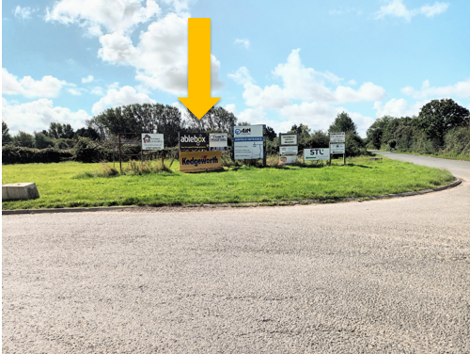

* Pass through the green gates and keep straight until you see another Kedgeworth sign and turn left (as per their arrow)

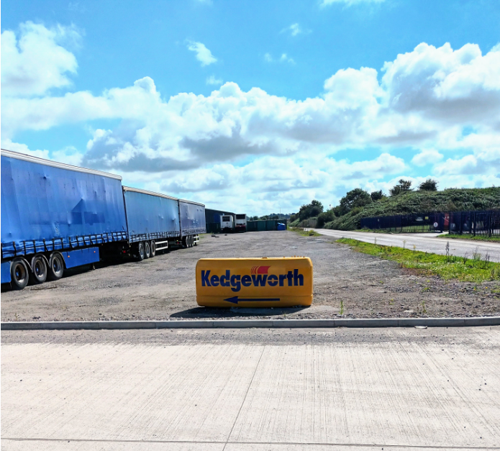

* Follow the road until you see the entrance to the Kedgeworth plant, and turn left on to the airfield
* There will be Salisbury Hospice flags to show you where to park
* On arrival at the airfield, come to the white marquee where the fundraising team will be waiting to welcome you – again, keep an eye out for our flags and bunting.